FROM INDUSTRY 1.0 TO INDUSTRY 4.0:
THE 4 INDUSTRIALS REVOLUTIONS
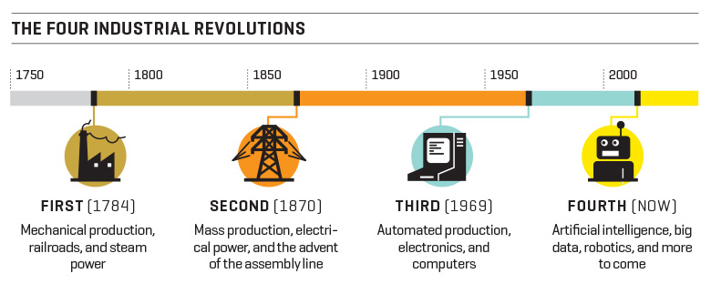
The 1st Industrial Revolution took place in Great Britain at the end of the 18th century. Thanks to the introduction of steam power and due to efficient transports, there was a transition from hand production methods to new manufacturing processes and mechanical automation. It was the rise of the factory system that spread all over the world.
The advent of electrical power at the end of 19th century and the introduction of the assembly line and of the conveyor belt in industries made production faster and more automated, giving way to mass production and to a process of full industrialization. That’s the 2nd Industrial Revolution.
The late 20th century saw another shift from traditional industry to an economy based on information (the 3rd Industrial Revolution). It’s the age of electronic automation and computer systems. Industrial manufacturing declined while the service sector started to grow, leading to a process of de-industrialization, or a decrease of industrial manufacturing in favour of the tertiary or service industry (information technology, telecommunications, finance and other services), tied to the advent of personal computers.
In the early 2000s quaternary industries took over (the 4th Industrial Revolution). Artificial intelligence, big data, robotics and cyber physical systems are the protagonists of this smart revolution, where the machine themselves, in an interaction and exchange of information, make the production highly automated and efficient.
