THE DIESEL ENGINE
- The diesel engine was invented in 1893 by Rudolf Diesel.
- It is also called compression-ignition engine.
- It does not need an electric spark to be started.
- When the ignition key is turned to start, the fuel passes through a couple of fuel filters, in order to be cleaned before reaching the injector noozles.
- The fuel is sprayed into the combustion chambers through fuel injector nozzles just when the air has been placed under great pressure.
- The temperature of the combustion chamber is hot enough to ignite the fuel spontaneously.
- The combustion chamber is usually pre-heated.

DIESEL ENGINE VS. GASOLINE ENGINE
Similarities
- Both have the basic four-strokes (intake – compression – power - exhaust)
Differences
- Gasoline engines need an electric spark to produce combustion while in diesel engines the ignition happens spontaneously.
- In gasoline engines, the fuel injected in the combustion chamber is a pre-mixture of air and gasoline while in diesel engine the fuel doesn’t properly mix with air and it is sprayed in an atomized way into high temperature air, so mixing happens only during the combustion.
- Diesel engines use a fuel injector while gasoline engines use a spark plug.
- Gasoline engines are less noisy and vibrates less than diesel ones because the combustion process is smooth and propagates well.
- Diesel ingines require a more rugged structural design than gasoline engines.
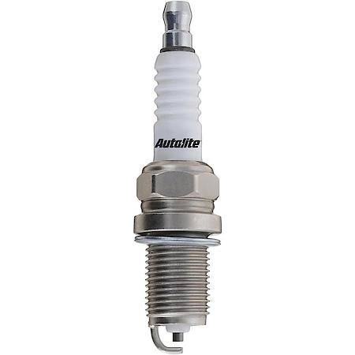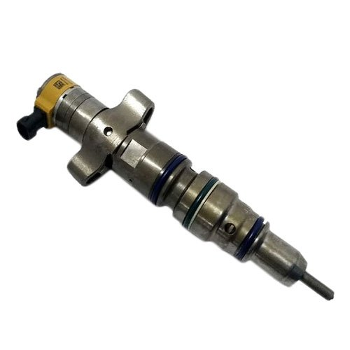
- Diesel engines can achieve a higher compression without risk of self-ignition while in gasoline engine it’s not possible. The higher the compression ratio the better the efficiency of the cycle. That’s why diesel engines have better fuel economy as compared to gasoline engines.

DIESEL ENGINE | GASOLINE ENGINE
Four-stroke engine | Four-stroke engine
Use fuel injectors to make fuel reach the combustion chamber | Use spark plugs to start the combustion process
The fuel doesn’t need an electric spark to be burnt | The fuel needs an electric spark to be ignited
Diesel fuel is less volatile, doesn’t mix properly with air,  mixing happens during the combustion | Gasoline is volatile and easily mixes with air, gasoline and air are pre-mixed before reaching the combustion chamber
High compression in the combustion chambers | Compression is lower to avoid self- ignition
Better fuel economy
More rugged and costly engine

