FORDISM AND TAYLORISM
HENRY FORD AND THE MODEL T

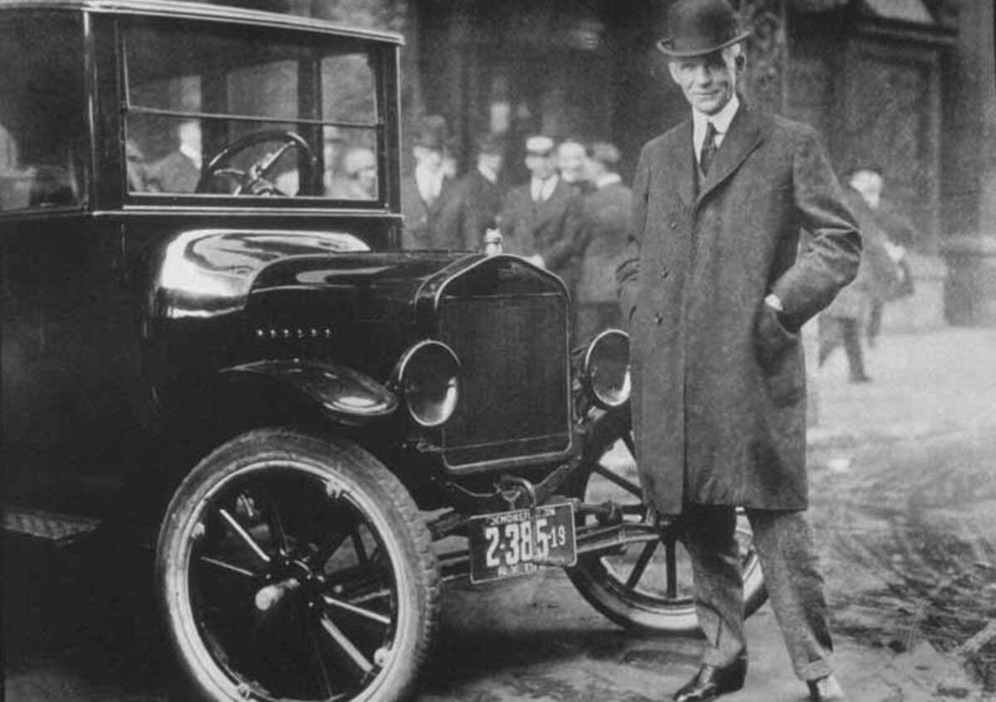

Henry Ford was one of the protagonists of the XXth century, the age of the Second Industrial Revolution. Ford pioneered the modern model of mass production which bears his name (FORDISM), and which is often said to date from the development of the first moving assembly lines, put into operation at Ford’s Model T plant at Highland Park, Michigan in 1914. It was a revolutionary method: the conveyor belt brought pieces in front of the worker, who performed and specialized in a single and repetitive task. No skilled workers were needed anymore.
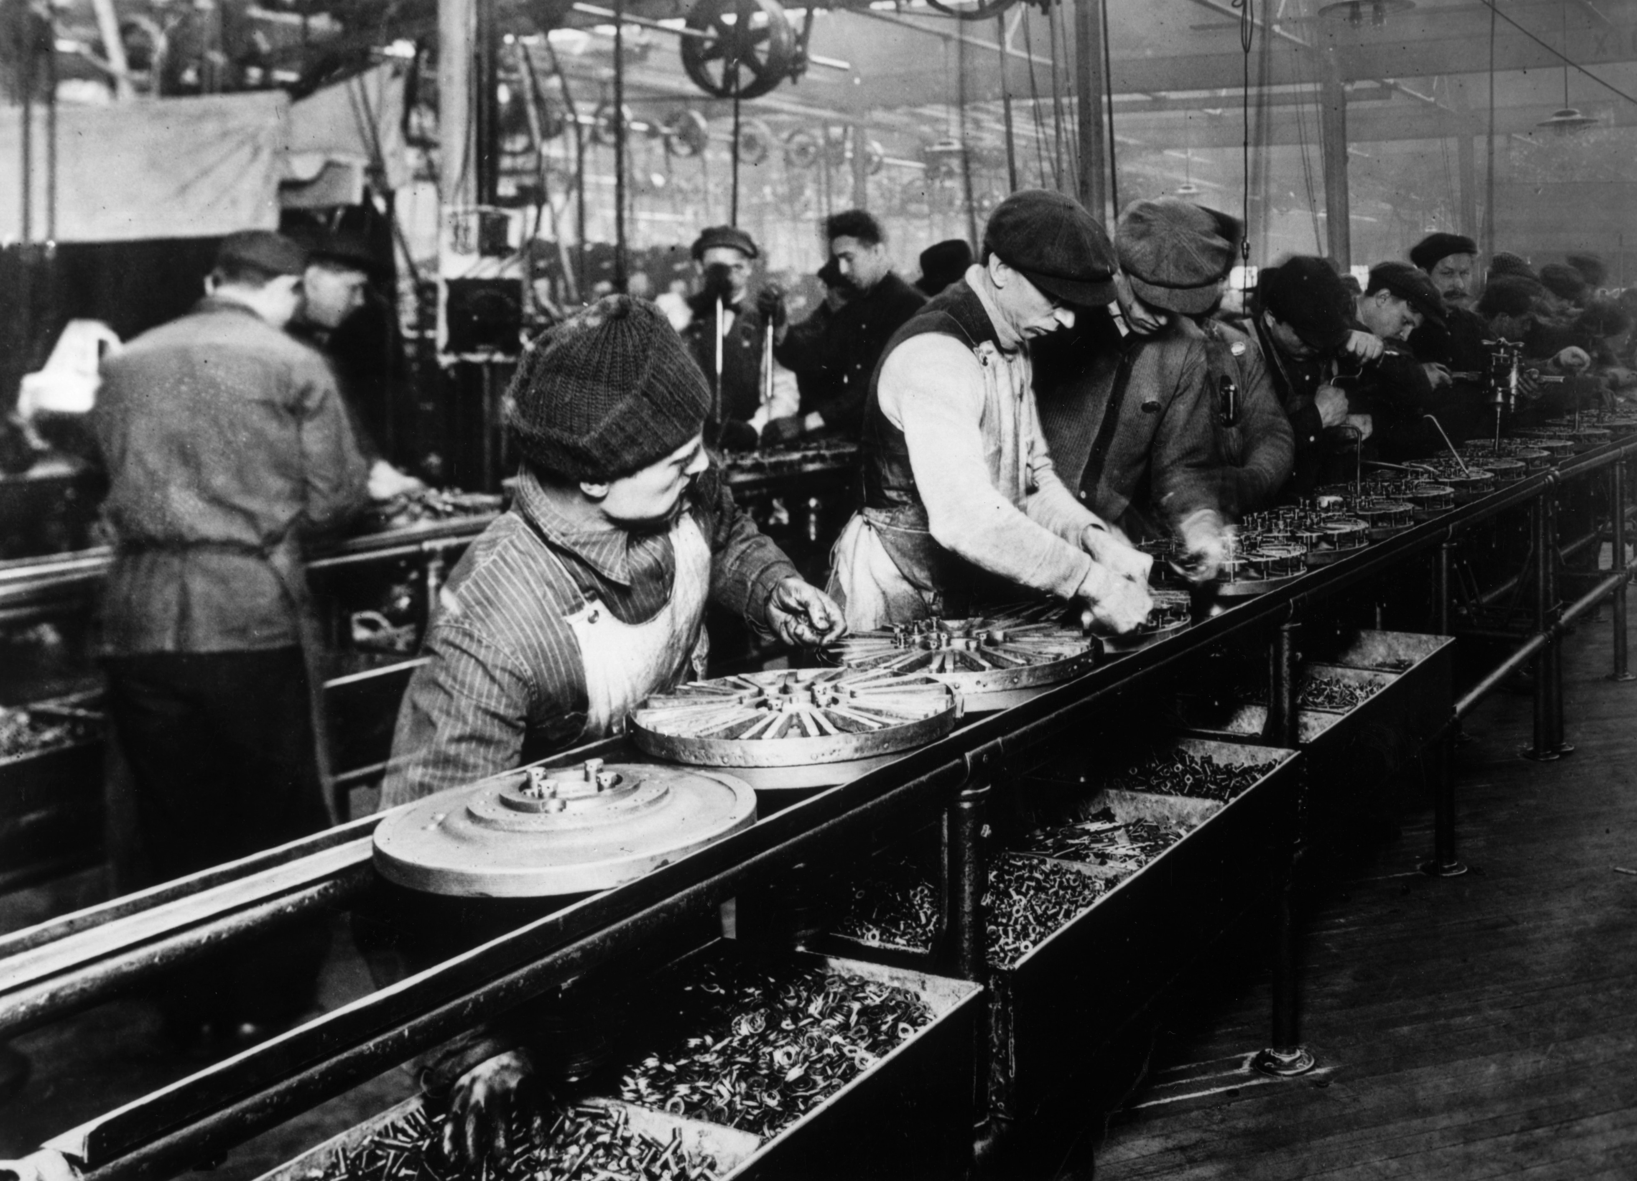

The assembly line increased labor productivity tenfold (=10 volte) and permitted stunning price cuts in Ford cars: from $780 in 1910 to $360 in 1914. Fordism thus involved standardizing a product and manufacturing it by mass means at a price so low that the common man could afford to buy it. Mass production and consumism were born.

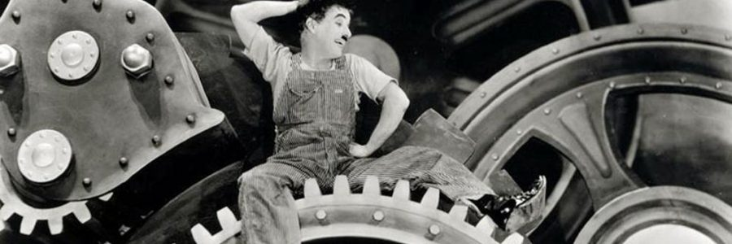
Ford raised workers’ wages so to allow them to buy by themselves the same “model T” car they produced. In that way, working class people became producer as well as consumer at the same time.

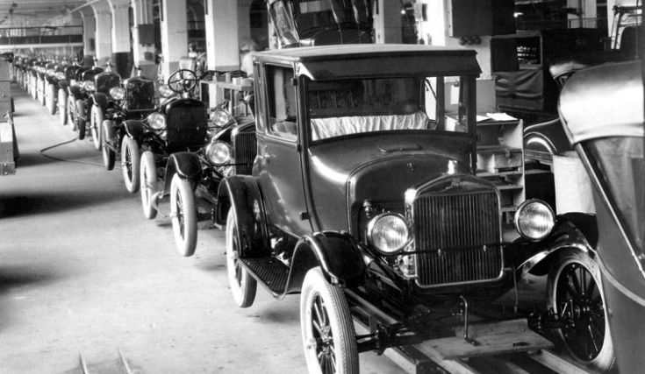

The operation was highly efficient from the commercial point of view; but it was harshly criticized because of the intensification of labor, the acceleration of rhytms of production and the elimination of craft-based production in which skilled laborers exercised substantial control over their conditions of work.
Fordist production entailed an intensified industrial division of labor; increased mechanization and coordination of large scale manufacturing processes (e.g., sequential machining operations and converging assembly lines) to achieve a steady flow of production; a shift toward the use of less skilled labor performing, ad infinitum, tasks minutely specified by management; and the potential for heightened capitalist control over the pace and intensity of work.
FREDERICK TAYLOR AND THE SCIENTIFIC MANAGEMENT
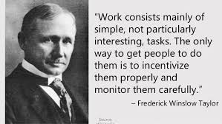
Ford’s industrial model put into practice the ideas of Frederick Taylor’s “Principles of Scientific Management " that would become the standard for businesses worldwide, a method also known as "Taylorism or industrial engineering”.
Taylor devised a means of detailing a division of labor in time-and-motion studies and a wage system based on performance. In front of a technical problem, he asserted, just a single solution is possible and the best production could be reached if the worker doesn’t think about what he is doing, but he performs a single and repetitive task. Whoever works fastly should be rewarded economically.
The main elements of the Scientific Management are: time studies (e.g., screw on each bolt in 15.2 seconds), standardization of tools and implements, the use of "slide-rules and similar time-saving devices", instruction cards for workmen (detailing exactly what they should do), task allocation (the concept of breaking task into smaller and smaller tasks). According to Taylor,
Taylor’s principles could be summarized into the following ones:
- Replace rule-of-thumb work methods with methods based on a scientific study of the tasks.
- Scientifically select, train, and develop each employee rather than passively leaving them to train themselves.
- Provide "Detailed instruction and supervision of each worker in the performance of that worker's discrete task".
- Divide work nearly equally between managers and workers, so that the managers apply scientific management principles to planning the work and the workers actually perform the tasks, respecting rules, labor division, times requested.
Perhaps the key idea of scientific management and the one which has drawn the most criticism was the concept of task allocation. Task allocation is the concept that breaking task into smaller and smaller tasks allows the determination of the optimum solution to the task. "The man in the planning room, whose speciality is planning ahead, invariably finds that the work can be done more economically by subdivision of the labour; each act of each mechanic, for example, should be preceded by various preparatory acts done by other men." A job that had, as a consequence, a depersonalising effect.

Ford and Taylorism
https://www.youtube.com/watch?v=vK0BjIA6njs

