Exhibition

Nowadays food seems to be dominated by an iconic-hedonistic trend that does not match with its wider and deeper meaning: culture. We live in a time where, never like today “people have ever talked so much about food but they actually don’t cook”. This trend brings food towards an aesthetic dimension which is disconnected from the deeper dimension of human life, such as the tangible level of acting, the art of doing, producing, exchanging, working, knowing, being together, welcoming, the inviolable right to life, tradition and spirituality. In a few words, the sustainability of life.

This is why Steve Mc Curry’s food photos, exhibited for the first time in Forlì, tell about food life cycle, from production to consumption, with a meaning that goes beyond their aesthetic value and forces us to a deeper reflexion and awareness effort on how food, fundamentally important for life, is actually present in different ways on different parts of the Planet.

Steve McCurry is well known for his ability to catch the unique moment of heroic daily life, the capacity to fix intriguing and surprising nuances on gestures and faces, to tell stories that are able to dig down in the observer’s sensitivity, involving the observer in the amazement and wonder of those who had the privilege to be there, when the scene occurred. The common trait of his images is the search for the universe inside the details; the extraordinary ability, within the small space of a photo, to tell the full story of a person, a community, a Country. A sort of visual metonymy, where one part stands for the whole and evocation becomes a higher value than representation, both in terms of quantity and quality.
With regard to “Cibo” exhibition, this desire to transfer the details of a story into the universal dimension of an epic tale, is incredibly powerful. Every photo is a paradigm. This applies to the moving images of people who consume their meal in solitude or in pain, and to the fragments of markets where fish, fruits or spices overcome the limit of the gaze and transmit smell, taste, emotional participation into a reality that, despite the differences, brings us back to the equality of human beings that share a piece of history, world, life.

The same goes for the part dedicated to work, preparation and exchange of food, which preserves the sacred dignity of life. And the same goes for the shots where eating together means conviviality, sharing and symbolic exchange.

As Plutarch said “We don’t meet to drink and eat, but rather to drink and eat together”.

Mc Curry’s 79 images, in a crescendo of emotions consisting of shapes, colours and sincere participation, take us there, where somebody always prevents us from going, towards an ideal convivium where the face features, the skin colour, the clothes, the places and the habits mix up in a large humanity pot that makes us feel united despite our differences. It makes us feel part of the large world canteen.

With “Cibo” and thanks to Steve Mc Curry’s artistic power, the “Mostre del Buon Vivere” exhibition series continues and evolves itself. This is the ideal manifesto where art is the universal language that makes us protagonists of a social, ethical and cultural reflexion, which goes from our eyes penetrating into our brain and soul.
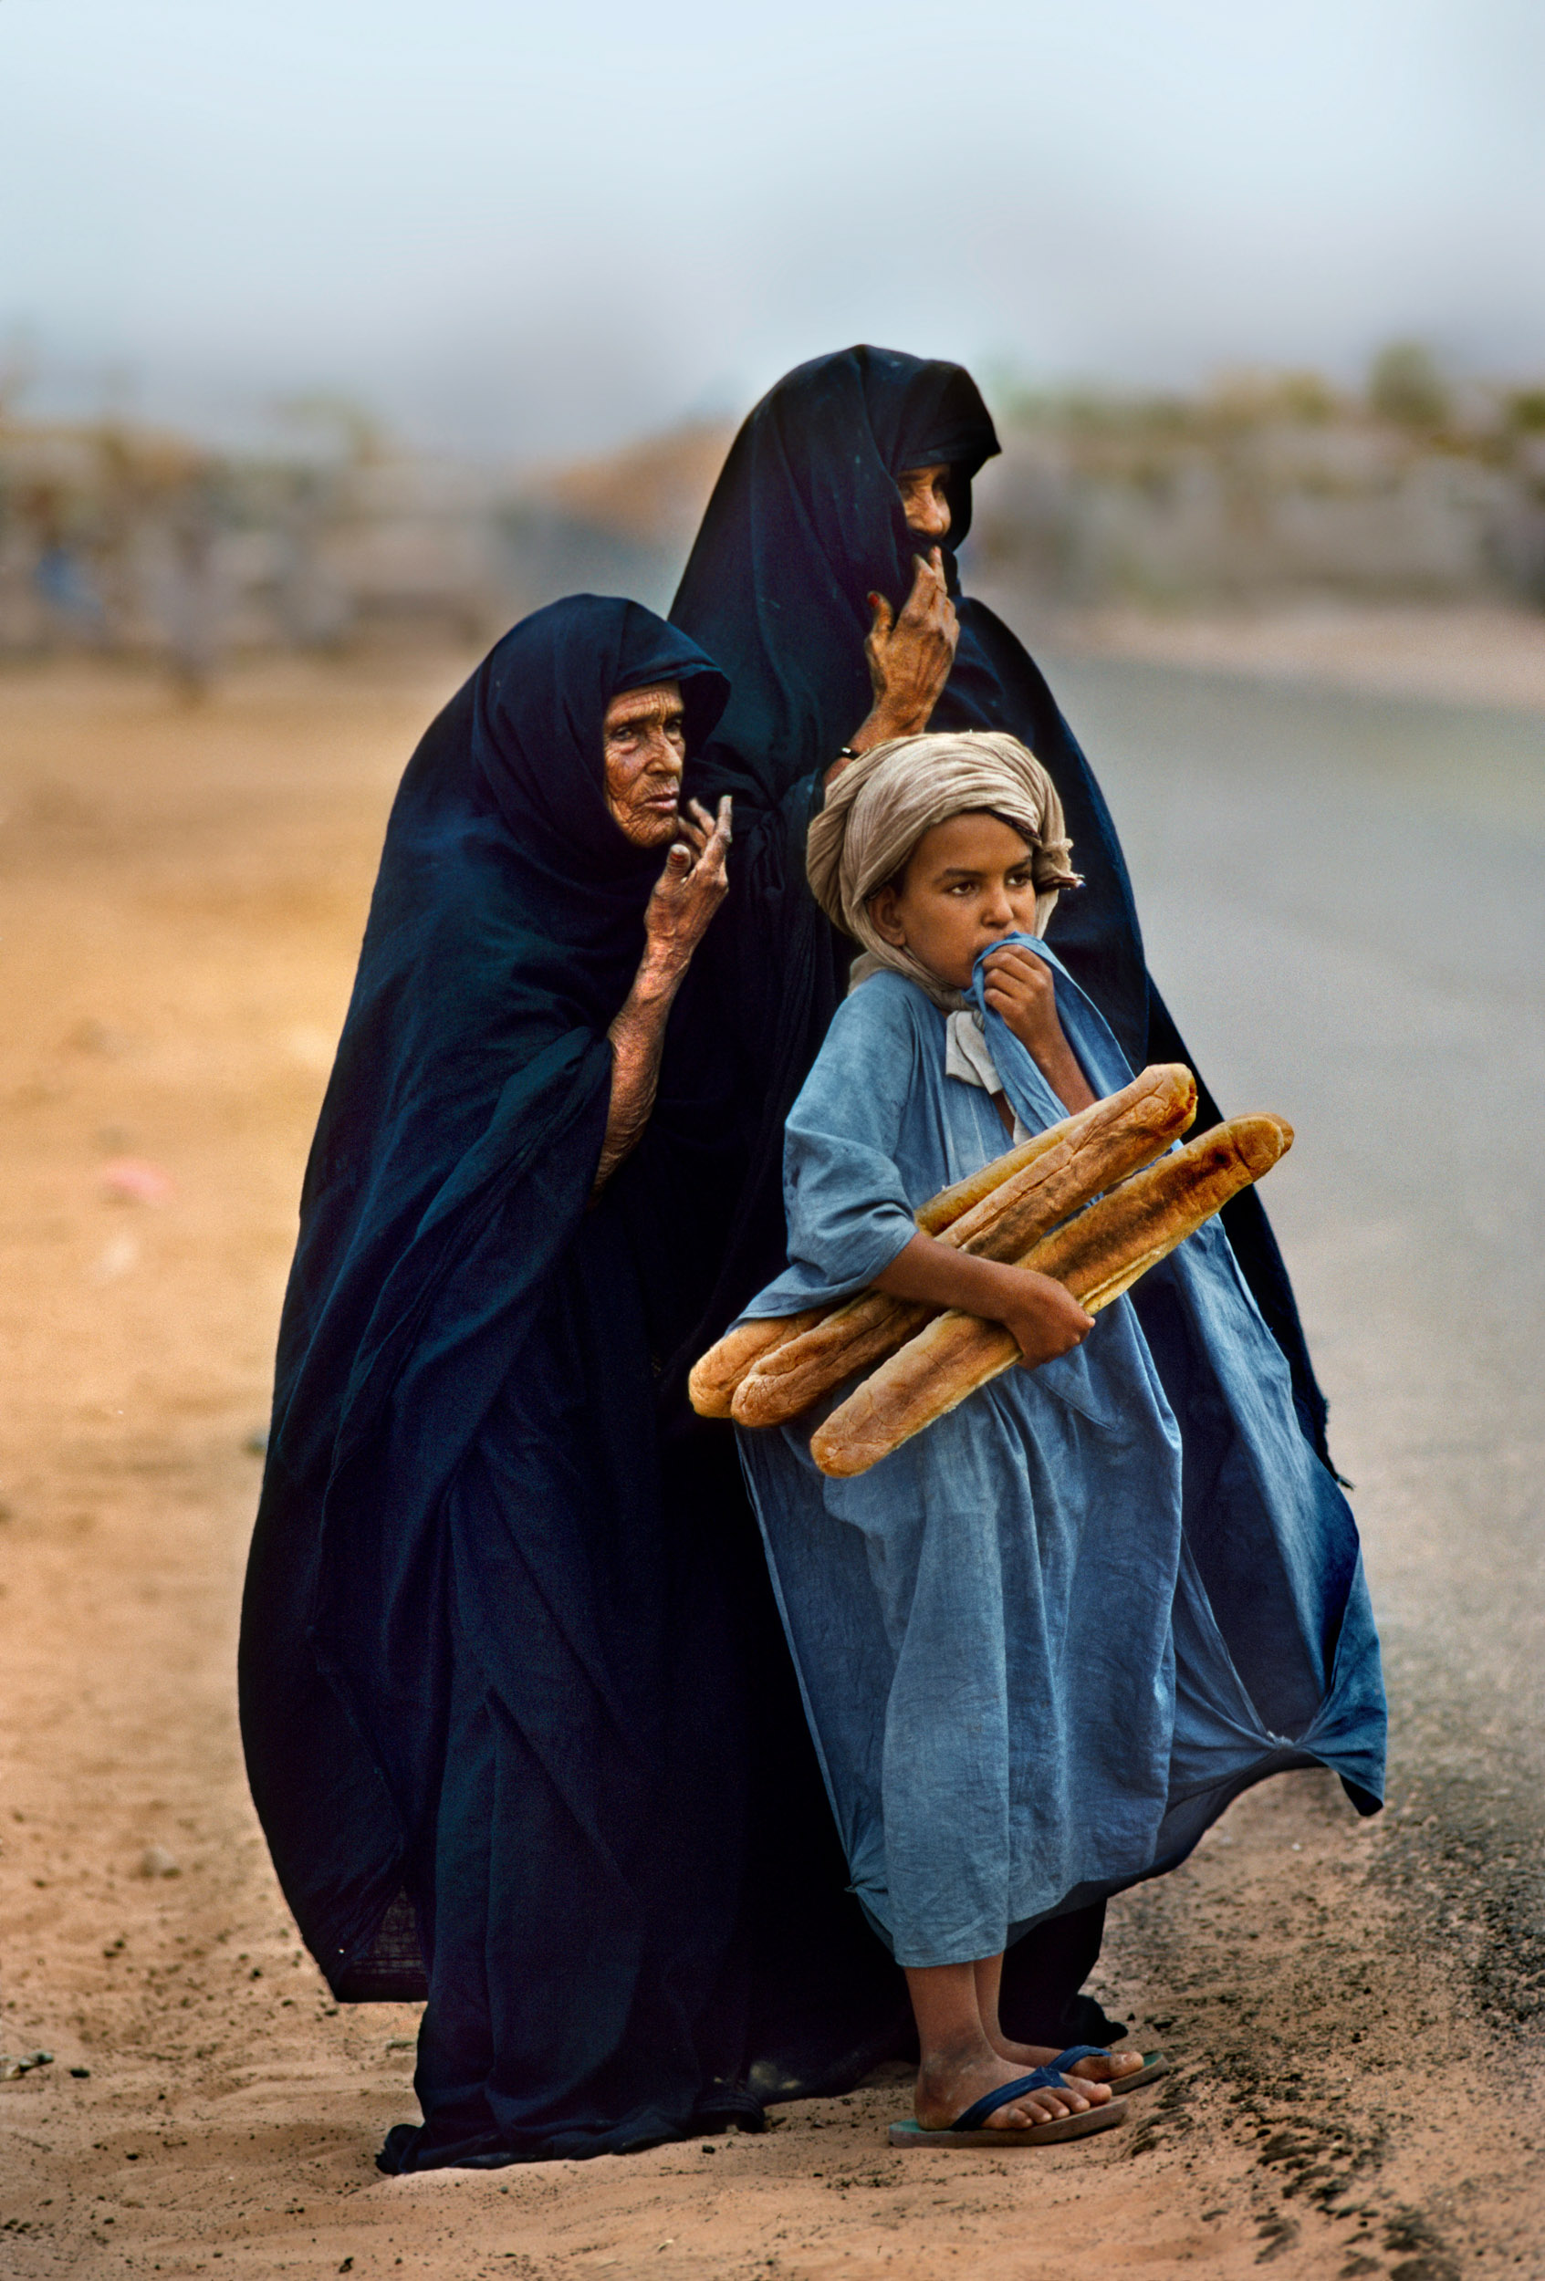

Steve McCurry

Steve McCurry has been one of the most iconic voices in contemporary photography for more than 30 years, with scores of magazine and book covers, over a dozen books, and countless exhibitions around the world to his name.
Born in a suburb of Philadelphia, Pennsylvania; McCurry studied film at Pennsylvania State University, before going on to work for a local newspaper. After several years of freelance work, McCurry made his first of what would become many trips to India. Traveling with little more than a bag of clothes and another of film, he made his way across the subcontinent, exploring the country with his camera.

It was after several months of travel that he found himself crossing the border into Pakistan. There, he met a group of refugees from Afghanistan, who smuggled him across the border into their country, just as the Russian Invasion was closing the country to all western journalists. Emerging in traditional dress, with full beard and weather-worn features after weeks embedded with the Mujahedeen, McCurry brought the world the first images of the conflict in Afghanistan, putting a human face to the issue on every masthead.

Since then, McCurry has gone on to create stunning images over six continents and countless countries. His work spans conflicts, vanishing cultures, ancient traditions and contemporary culture alike – yet always retains the human element that made his celebrated image of the Afghan Girl such a powerful image.

McCurry has been recognized with some of the most prestigious awards in the industry, including the Robert Capa Gold Medal, National Press Photographers Award, and an unprecedented four first prize awards from the World Press Photo contest. The Minister of French Culture has also appointed McCurry a Knight of the Order of Arts and Letters and most recently, the Royal Photographic Society in London awarded McCurry the Centenary Medal for Lifetime Achievement.

McCurry has published books including The Imperial Way (1985), Monsoon (1988), Portraits (1999), South Southeast (2000), Sanctuary (2002), The Path to Buddha: A Tibetan Pilgrimage (2003), Steve McCurry (2005), Looking East (2006), In the Shadow of Mountains (2007), The Unguarded Moment, (2009), The Iconic Photographs (2011), Untold: The Stories Behind the Photographs (2013), From These Hands: A Journey Along the Coffee Trail (2015), India (2015), and On Reading (2016), Afghanistan (2017).
