The little smuggler

Over the wall, through holes, and past the [...]
Through the wires, ruins and fences,
Plucky, hungry and determined
I sneak through, dart like a cat…

And if the Hand of destiny
Should seize me in the game,
That’s a common trick of life.
You, mother, do not wait up for me…

And only one request
Will stiffen on my lips:
Who, mother mine, who
Will bring your bread tomorrow?

Henryka Lazowert, 1910-1942 A Polish poet, Lazowert
was deported with her mother to Treblinka during the
Great Deportation. Both women were murdered there.

Source: Yad Vashem, Memoriale dell’Olocausto, Jerusalem
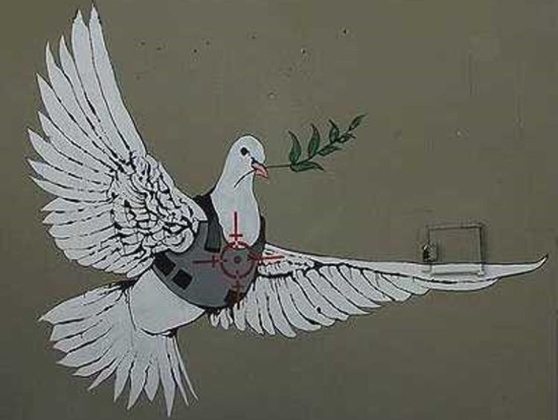

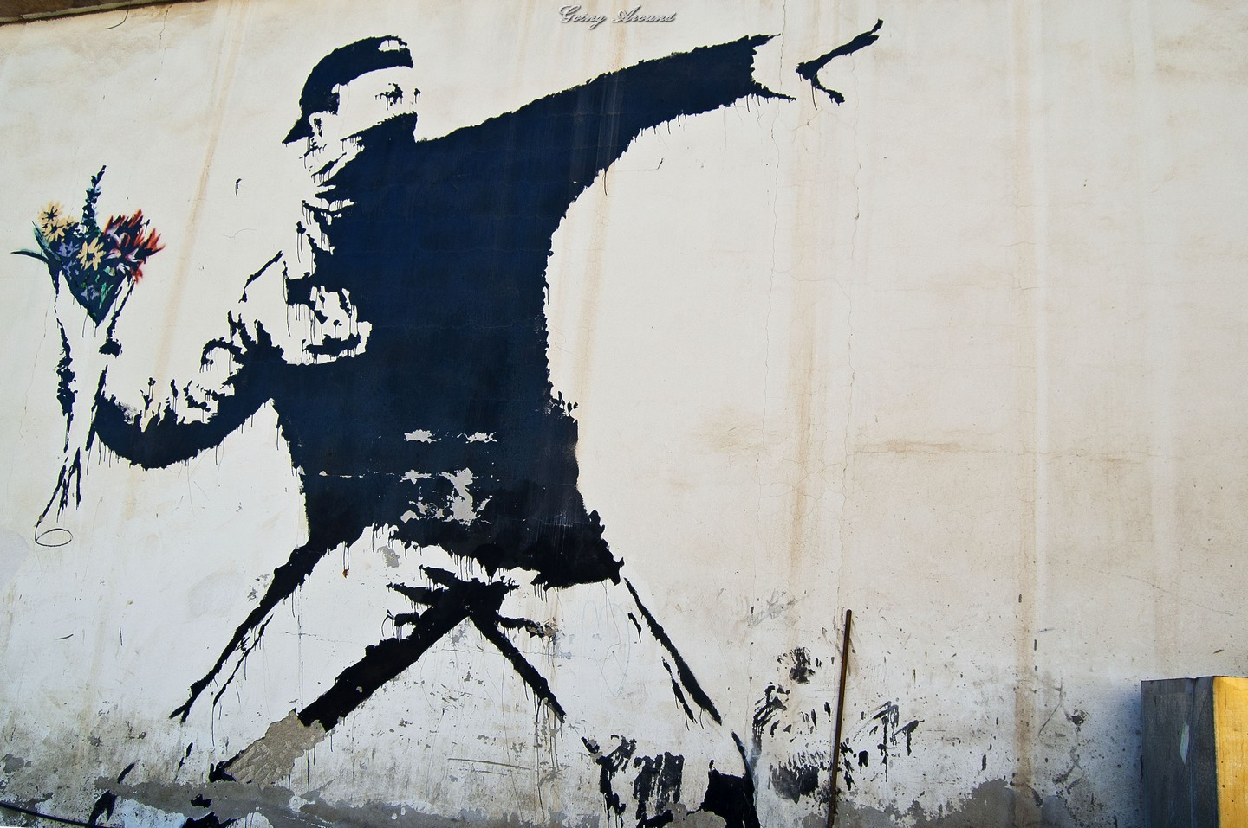

Basky, writer and street artist
"The Little Smuggler" (Polish: Mały szmugler) is a famous poem by the Polish poet Henryka Łazowertówna (1909–1942). Written in the Warsaw Ghetto during the Holocaust, it tells the story of a small child who supports his starving family by — illegally, under Nazi dispensation — bringing over food supplies from the "Aryan side", thereby allowing for his family's survival while at the same time risking his own life. Indeed, the last stanza of the poem gives expression to the heroic child's fear — not of his own death but that of his mother who, in the event of the loss of her child, would be left without her daily sustenance.

The Warsaw Ghetto
In 1941 the official daily food rations distributed on the basis of ration cards were allocated by the Nazis according to the following ethnically dif­fe­ren­ti­ated scale: the Germans were allotted 2,613 calories per day, the Poles, 669, while persons of Jewish origin were allowed only 184 calories a day, a diet insufficient for survival.^{[1]} Consequently, in the Warsaw Ghetto fully eighty percent of all food consumed had to be smuggled in as illicit contraband.^{[2]} Only those with access to smuggled food, and the very rich able to afford to buy provisions on the black market within the Ghetto at exorbitant prices, stood a chance of survival. For most, children were the best hope for bringing supplies over from the "Aryan side" as they could slither undetected through small openings and sewer lines on their way to and from the Ghetto. These child heroes, as noted by the historian Richard C. Lukas, saved or prolonged the lives of countless adult individuals.^{[3]} But they themselves fell victim in large numbers to the bullets of German police.^{[4]}
Already during the Holocaust the poem "Mały szmugler" enjoyed a sufficient degree of fame and popularity to be translated from the Polish into Yiddish and, set to music, performed to great acclaim by Diana Blumenfeld.^{[5]} The poem — as recited by Łazowertówna herself in August 1941 — moved the hearts of her contemporary listeners so deeply that Emanuel Ringelblum is able to report the voices of those who insisted that, once the Ghetto becomes liberated after the War, it should host a monument dedicated to the Unknown Smuggler depicted in the poem.^{[6]}
However, the Warsaw Ghetto was never liberated; it was "liquidated" by the Nazis in various stages over several months beginning in July 1942, with the result of the hundreds of thousands of residents who had not previously died of starvation or disease — men, women, and children — having been me­thod­i­cally murdered in organized genocide, while the actual municipal structure of the whole precinct was razed to the ground.^{[7]} The author of the poem, Henryka Łazowertówna, together with her mother, Bluma Łazowertowa, were themselves killed in the gas chambers of the Treblinka extermination camp.^{[8]}

Source: Wikipedia
